Bogotá, Colombia 05 de Febrero del 2014

Esteemed Editor
Dr. Alberto Acosta Universitas Scientiarum

We are pleased to remit the manuscript entitled " Polymer Characterization and Influence in the Rhizobium-Cowpea [Vigna unguiculata (L.) Walp] Interaction to consider its approval and publication in the Journal Scientiarum Universitas. Authors: Diego Rivera, Melissa Obando, Helber Barbosa, Daniel Rojas-Tapias, Ruth Bonilla.
This research work sought primarily the application of new technologies focused on polymers that are potentially important new materials that can be used for the formulation of biofertilizers; integrating these substances with biological systems will provide innovative solutions and technological advances that will promote sustainable benefits for the environment. This research is very interesting, because it allows for innovation in new biotechnological applications of microorganisms of industrial interest en legumes cultivation.
We sought through research, the controlled release of the active "Rhizobium" to improve fertilization and prevalence of the microorganism in favor of staying steady on the floor.
All authors have contributed intellectually in this work, in the conception and design, gathering authorship conditions and approving the final version. Likewise, we emphasize the originality, the non previous publication or the revision process in other magazine or journal of this work original.
International reviewers:
Ph.D. Vera Divan Baldani [Expert in Applied Microbiology/Agricultural Biotechnology /Embrapa Agrobiotecnología] email: vera@cnpab.embrapa.br
Ph.D. Alexander Resende [Expert in Applied Microbiology/Agricultural Biotechnology /Embrapa Agrobiotecnología] email: alex@cnpab.embrapa.br
Ph.D. Inés García de Salamone [Expert in Applied Microbiology/Agricultural Biotechnology /Universidad de Buenos Aires] email: igarcia@agro.uba.ar
National reviewers
Ph.D. Sonia Amparo Ospina Sánchez [Expert in Applied Microbiology and Biotechnology /Universidad Nacional de Colombia] email: saospinas@unal.edu.co

Thank you for your attention and we look forward to your response…

Sincerely,
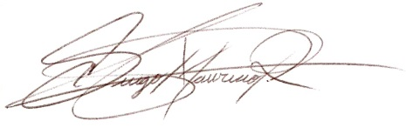
Diego Mauricio Rivera Author correspondence: dmriverab@unal.edu.co Móvil: 314-3042433 Attachment: Manuscript, two figures, cover letter

